**CFD Analysis of NACA 2415 Airfoil with a Velocity of 28 m/s**

**Abstract**

This report details a comprehensive Computational Fluid Dynamics (CFD) analysis of the NACA 2415 airfoil, conducted using Autodesk CFD. The simulation was performed under steady-state, incompressible, and turbulent flow conditions with an inlet velocity of 28 m/s. The primary objective was to evaluate key aerodynamic characteristics, including lift, drag, pressure distribution, and velocity profiles, utilizing the robust k-ε turbulence model. This analysis aims to provide a deep understanding of the complex flow physics around the airfoil and to identify specific avenues for aerodynamic optimization, particularly for applications in UAVs and racing vehicles. The report covers the theoretical foundation of governing equations, the meticulous simulation methodology, boundary conditions, solver settings, detailed post-processing and interpretation of results, and actionable design recommendations.

**1. Introduction**

The NACA 2415 airfoil is a widely recognized and utilized cambered profile, characterized by its moderate thickness and efficient lift-producing capabilities. Its applications span various low-speed aerodynamic contexts, including light aircraft, Unmanned Aerial Vehicles (UAVs), and high-performance Formula Student racing cars. A thorough understanding of its aerodynamic performance under realistic operating conditions is paramount for optimizing design, enhancing efficiency, and ensuring stability.

Computational Fluid Dynamics (CFD) offers an invaluable non-intrusive and cost-effective alternative to traditional experimental methods like wind tunnel testing. By numerically solving the governing equations of fluid flow, CFD enables detailed visualization and quantitative analysis of complex flow behaviors, providing insights that are often difficult or impossible to obtain experimentally. This analysis leverages the power of CFD to predict the aerodynamic forces and flow patterns around the NACA 2415 airfoil, thereby facilitating informed design decisions and iterative improvements.

**2. Governing Equations**

The foundation of any CFD simulation lies in the fundamental conservation laws of physics, expressed mathematically as partial differential equations. For this analysis, which considers steady-state, incompressible, and turbulent fluid flow, the primary governing equations are the Continuity Equation, the Navier-Stokes Equations, and the equations associated with the chosen turbulence model.

**2.1. Continuity Equation (Mass Conservation)**

The Continuity Equation is an expression of the principle of mass conservation, stating that mass can neither be created nor destroyed within the flow domain. For an incompressible fluid, where density is assumed constant, this equation simplifies to:

∇⋅V=0

Where V represents the fluid velocity vector. This equation ensures that the net mass flow rate into any infinitesimal control volume within the fluid domain is zero, thereby maintaining mass balance.

**2.2. Navier-Stokes Equations (Momentum Conservation)**

The Navier-Stokes Equations are the cornerstone of fluid dynamics, representing the conservation of momentum. They describe the balance between inertial forces, pressure forces, and viscous forces acting on a fluid element. For a steady-state flow, these equations can be written as:

ρ(V⋅∇V) = −∇P + μ∇^2V

Where:

* ρ is the fluid density.
* P is the static pressure.
* μ is the dynamic viscosity of the fluid.

The left side of the equation represents the inertial forces (convective acceleration), while the right side accounts for pressure gradients and viscous stresses. Solving these equations provides the velocity and pressure fields throughout the computational domain.

**2.3. Turbulence Modeling: The k-ε Model**

Turbulent flow is characterized by chaotic, unsteady, and highly three-dimensional fluid motion. Direct numerical simulation (DNS) of turbulent flows is computationally prohibitive for most engineering applications due to the wide range of scales involved. Therefore, turbulence models are employed to approximate the effects of turbulence on the mean flow.

The **k-ε (k-epsilon) turbulence model** is a two-equation eddy-viscosity model that has gained widespread acceptance for its robustness, computational efficiency, and reasonable accuracy across a broad range of industrial applications. It introduces two additional transport equations:

* **Turbulent Kinetic Energy (**k**):** Represents the kinetic energy associated with the fluctuating components of velocity. Its transport equation accounts for its production, convection, diffusion, and dissipation.
* **Turbulent Dissipation Rate (**ϵ**):** Represents the rate at which turbulent kinetic energy dissipates into thermal energy due to viscous forces. Its transport equation similarly accounts for its production, convection, diffusion, and dissipation.

The k-ε model calculates an effective turbulent viscosity, which is then used in the Reynolds-averaged Navier-Stokes (RANS) equations to account for the turbulent stresses. This approach allows for the simulation of turbulent flows without resolving every turbulent eddy, significantly reducing computational cost.

**3. Simulation Setup**

A meticulously planned simulation setup is crucial for obtaining accurate and reliable CFD results. This section details the specifics of the geometry, material properties, boundary conditions, meshing strategy, and solver settings employed in the Autodesk CFD analysis.

**3.1. Geometry and Domain**

The NACA 2415 airfoil was precisely modeled within a 3D Cartesian computational domain. The dimensions of this domain were carefully chosen to be sufficiently large, extending in all directions around the airfoil, to ensure that the boundaries did not unduly influence the flow patterns around the airfoil. The airfoil itself was positioned centrally within this domain to minimize any artificial effects from the domain walls. The overall setup aimed to replicate an unbounded, open-flow environment as closely as possible.

**3.2. Material Properties**

The physical properties of the fluid and solid materials are fundamental inputs for the simulation:

* **Fluid Medium (Air):** The flow medium was defined as standard air. Its properties were set as:
  + **Density (**ρ**):** 1.225 kg/m³ (assumed constant for incompressible flow).
  + **Dynamic Viscosity (**μ**):** 1.817×10−5 Pa
  + **Specific Heat:** 1004.0 J/kg-K
  + **Conductivity:** 0.02563 W/m-K
  + **Compressibility:** 1.4 (adiabatic index, though incompressible flow was assumed for the primary solution).
* **Airfoil Material (Aluminum):** The airfoil structure itself was modeled as Aluminum, with the following properties:
  + **Density (**ρ**):** 2707 kg/m³.
  + **Thermal Conductivity:** 204 W/mK (isotropic).
  + **Specific Heat:** 896.0 J/kg-K.

**3.3. Boundary Conditions**

Boundary conditions define the interaction of the fluid with the computational domain's boundaries and the airfoil surface. Accurate specification of these conditions is vital for a physically realistic simulation:

* **Inlet:** A uniform **velocity inlet** boundary condition was applied at the upstream face of the computational domain. The velocity was set to 28 m/s and was directed normal to the inlet plane. This represents the free-stream flow approaching the airfoil.
* **Outlet:** An **ambient pressure outlet** boundary condition was applied at the downstream face. The pressure was set to 0 Pa (gauge pressure), allowing the fluid to exit the domain freely.
* **Airfoil Surface:** A **no-slip wall condition** was imposed on the entire surface of the NACA 2415 airfoil. This condition dictates that the fluid velocity at the wall is zero relative to the wall itself, accounting for viscous effects at the solid-fluid interface.
* **Other Walls (Sides, Top, Bottom of Domain):** **Symmetry** or **slip conditions** were applied to these boundaries. A symmetry condition implies that there is no flow across the boundary and no scalar flux across it, effectively simulating an infinitely wide flow field. Slip conditions allow flow parallel to the boundary but prevent flow normal to it, mimicking an inviscid wall or a free-stream boundary far from the airfoil.

**3.4. Meshing Details**

Meshing, or grid generation, involves discretizing the continuous computational domain into a finite number of discrete elements. The quality and resolution of the mesh directly impact the accuracy and stability of the CFD solution.

Autodesk CFD's automatic mesh generator was utilized for this purpose. The resulting mesh consisted of approximately **59,884 tetrahedral elements** and **15,826 nodes**. Tetrahedral elements are versatile and well-suited for complex geometries like airfoils.

A critical aspect of the meshing strategy was the implementation of **prism layers (inflation layers)** near the airfoil surface. These layers consist of structured, high-aspect-ratio elements that are extruded normal to the wall. Their purpose is to accurately resolve the **boundary layer**, which is a thin region of fluid near the wall where viscous effects are dominant and steep velocity gradients occur. By capturing these gradients effectively, the mesh ensures accurate prediction of wall shear stresses and pressure distributions. The mesh enhancement settings included 3 layers with a layer factor of 0.45 and layer gradation of 0.0.

**Automatic Meshing Settings:**

|  |  |
| --- | --- |
| Parameter | Value |
| Surface refinement | FALSE |
| Gap refinement | Value |
| Resolution factor | 1.0 |
| Edge growth rate | 1.1 |
| Minimum points on edge | 2 |
| Points in longest edge | 10 |
| Surface limiting aspect ratio | 20 |

**Mesh Enhancement Settings:**

|  |  |
| --- | --- |
| Parameter | Value |
| Mesh enhancement | TRUE |
| Enhancement blending | FALSE |
| Number of layers | 3 |
| Layer factor | 0.45 |
| Layer gradation | 0 |

**Resulting Mesh Metrics:**

|  |  |
| --- | --- |
| Metric | Value |
| Number of Nodes | 21041 |
| Number of Elements | 87772 |

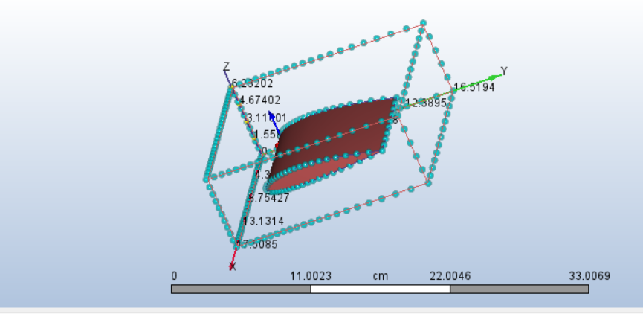

**3.5. Solver Settings**

The solver settings dictate how the numerical equations are solved and the overall simulation strategy:

* **Solver Type:** The simulation was configured as **steady-state**, meaning the flow variables do not change with time after the solution converges. It was also a **pressure-based solver**, which is common for incompressible and low-Mach number flows.
* **Turbulence Model:** As discussed, the **k-ε turbulence model** was selected to account for turbulent effects.
* **Advection Scheme:** The **ADV5 advection scheme** was chosen. This is a high-order accuracy scheme, which helps in reducing numerical diffusion and capturing flow features more sharply, especially in regions with strong gradients.
* **Number of Iterations:** The simulation was run for **100 iterations**. The convergence plots indicated that the solution had reached a stable state within this number of iterations, with residuals dropping to acceptable levels.
* **Simulation Time:** The total computational time for the simulation was **283 seconds**.

**4. Post-Processing & Results Interpretation**

Post-processing involves extracting, visualizing, and interpreting the vast amounts of data generated by the CFD solver. This phase transforms raw numerical data into meaningful aerodynamic insights, allowing for a comprehensive understanding of the flow behavior around the NACA 2415 airfoil.

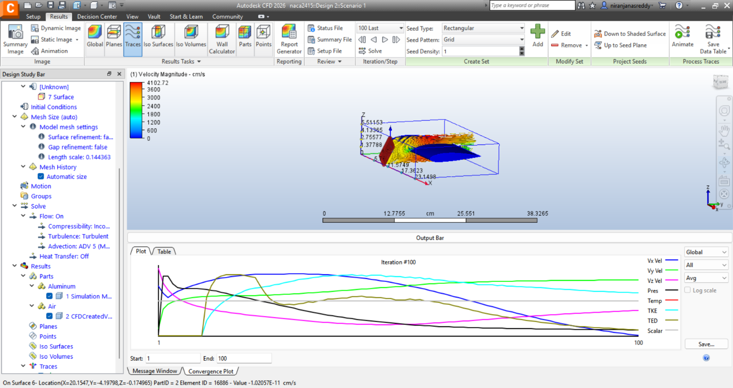

**4.1. Flow Characteristics**

The initial analysis of the flow conditions confirmed the assumptions made during the setup phase:

* **Reynolds Number:** Based on the airfoil's chord length and the inlet velocity of 28 m/s, the calculated Reynolds number was approximately **206,865**. This value falls within the range typically associated with **turbulent flow**, validating the choice of a turbulence model.
* **Mach Number:** The Mach number, which is the ratio of the flow velocity to the speed of sound, was approximately **0.078**. This low Mach number is significantly less than 0.3, which strongly justifies the **incompressible flow assumption**. For Mach numbers below 0.3, density variations due to compressibility effects are negligible, simplifying the governing equations and reducing computational cost.

The simulation successfully converged after 100 iterations, as indicated by the stable residuals, ensuring the reliability of the obtained results.

**4.2. Pressure Distribution**

The pressure distribution around the airfoil is a primary indicator of how lift and pressure drag are generated. The post-processing revealed distinct pressure zones:

* **High-Pressure Zone (Leading Edge):** A region of **high pressure** was observed at the leading edge of the airfoil. This is a classic characteristic of flow stagnation, where the incoming fluid particles slow down significantly or come to a complete stop, converting their kinetic energy into pressure energy.
* **Low-Pressure Zone (Upper Surface):** Conversely, a prominent **low-pressure zone** developed over the curved upper surface of the airfoil. As the air accelerates over the longer path of the upper surface, its static pressure decreases in accordance with **Bernoulli's principle**. This pressure differential between the lower (higher pressure) and upper (lower pressure) surfaces is the fundamental mechanism responsible for generating the upward lift force.
* **Pressure Recovery (Trailing Edge):** The pressure gradually recovered towards the trailing edge of the airfoil, approaching the ambient pressure. This recovery is crucial for minimizing pressure drag.

**4.3. Velocity Field**

The velocity field provides a visual and quantitative representation of how the fluid moves around the airfoil.

* **Velocity Acceleration (Upper Surface):** Consistent with the pressure distribution, the fluid velocity **increased significantly** as it flowed over the curved upper surface of the airfoil. This acceleration is a direct consequence of the low-pressure region, as the fluid is drawn into areas of lower pressure.
* **Maximum Velocity:** The maximum x-velocity component observed in the flow field reached approximately **15.67 m/s**. This velocity is considerably higher than the inlet velocity, demonstrating the airfoil's ability to accelerate the flow over its surface.
* **Minimal Flow Separation:** A crucial observation was the **minimal flow separation** from the airfoil's surface. This indicates that the flow remained largely attached to the airfoil, even around the curved sections. Attached flow is highly desirable for efficient aerodynamic performance, as flow separation leads to increased drag and reduced lift. The smooth curvature of the NACA 2415 airfoil contributed significantly to maintaining attached flow at the simulated conditions.

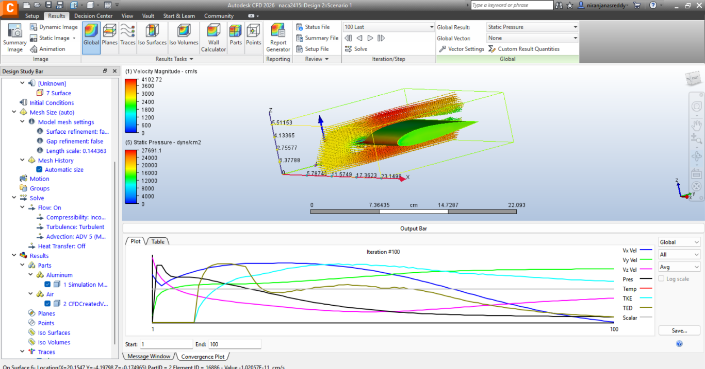

**4.4. Force Calculations**

The aerodynamic forces acting on the airfoil, namely lift and drag, were computed by integrating the pressure and shear stresses over the airfoil's surface. These values are direct quantitative measures of the airfoil's performance.

* **Lift Force (Y-direction):** The vertical component of the force, commonly known as lift, was found to be approximately **98,569 dynes**. This substantial lift force confirms the effective design of the NACA 2415 airfoil for generating upward force, making it suitable for applications requiring significant lift at low speeds.
* **Drag Force (X-direction):** The horizontal component of the force, or drag, was calculated to be approximately **13,129 dynes**. This moderate drag value indicates that while the airfoil generates significant lift, it also incurs a reasonable resistance to forward motion.
* **Shear Contributions:** The analysis further revealed that the **shear contributions** to both lift and drag were relatively small compared to the pressure forces. This implies that the overall aerodynamic performance is predominantly driven by the pressure distribution around the airfoil rather than viscous friction on the surface.

The ratio of lift to drag (L/D ratio), though not explicitly calculated in the provided data, would be a key metric derived from these forces, indicating the aerodynamic efficiency of the airfoil. A higher L/D ratio signifies better performance.

**5. Design Recommendations and Optimization**

Based on the detailed insights gained from the CFD simulation, several specific design recommendations and avenues for optimization can be proposed to further enhance the aerodynamic performance of the NACA 2415 airfoil. These recommendations aim to either increase lift, reduce drag, or improve overall stability.

**5.1. Increase Upper Surface Curvature for Enhanced Lift**

The simulation clearly demonstrated that the low-pressure zone over the upper surface is the primary driver of lift. By **increasing the curvature of the upper surface** (i.e., making it more convex), the air would be forced to travel an even greater distance in the same amount of time, leading to a more pronounced acceleration and, consequently, a further reduction in static pressure. This enhanced pressure differential between the upper and lower surfaces would directly result in a **higher lift force**. However, this must be carefully balanced, as excessive curvature can lead to premature flow separation at higher angles of attack or velocities, negating the lift benefits and significantly increasing drag. Iterative CFD simulations would be essential to find the optimal curvature.

**5.2. Sharpen Trailing Edge to Reduce Wake Turbulence and Drag**

The trailing edge of an airfoil plays a crucial role in how the flow separates and forms the wake behind the body. The current analysis indicated moderate drag. A significant component of drag, known as **form drag** or **pressure drag**, is associated with the shape of the object and the pressure differences it creates. By **sharpening the trailing edge**, the flow can detach more cleanly and smoothly from the airfoil. This reduces the size and intensity of the turbulent wake formed behind the airfoil, which is a major source of energy loss and drag. A cleaner flow separation leads to a smaller pressure difference between the front and rear of the airfoil, thus **reducing overall drag**. This optimization is particularly effective in minimizing the contribution of pressure drag.

**5.3. Modify Camber to Shift the Center of Pressure for Improved Stability**

**Camber** refers to the asymmetry between the upper and lower surfaces of an airfoil. The NACA 2415 is a cambered airfoil, meaning its mean camber line is curved. The **center of pressure** is the point on the airfoil where the total aerodynamic force acts. Its position is crucial for the stability and control of the aircraft or vehicle. By **modifying the camber** (e.g., increasing or decreasing the maximum camber, or shifting its location along the chord), the distribution of pressure over the airfoil can be altered. This, in turn, can shift the center of pressure. For example, moving the center of pressure forward or backward can influence the pitching moment of the airfoil, allowing for **improved longitudinal stability** or better control authority. This optimization would require careful consideration of the specific stability requirements of the application (e.g., UAV, racing car).

**5.4. Experiment with Different Angles of Attack for Stall Margin Analysis**

The current simulation was performed at a single, unspecified angle of attack. However, an airfoil's performance varies significantly with its **angle of attack (AoA)**, which is the angle between the airfoil's chord line and the direction of the incoming flow.

* **Lift and Drag Variation:** As the AoA increases, lift generally increases up to a certain point, while drag also increases.
* **Stall Behavior:** Beyond a critical angle of attack, the flow separates drastically from the upper surface, leading to a sudden and significant loss of lift and a sharp increase in drag. This phenomenon is known as **stall**.
* **Stall Margin:** Understanding the stall behavior and determining the **stall margin** (the difference between the operating AoA and the stall AoA) is paramount for safe and efficient operation.

Therefore, conducting **additional CFD simulations at varying angles of attack** is highly recommended. This would allow for the generation of comprehensive lift and drag curves (CL vs. AoA, CD vs. AoA), identification of the stall angle, and a detailed analysis of the flow field during pre-stall and post-stall conditions. This data is invaluable for defining the operational envelope of the airfoil and ensuring safe flight or vehicle dynamics.

**6. Conclusion**

The Computational Fluid Dynamics (CFD) analysis of the NACA 2415 airfoil, performed using Autodesk CFD at an inlet velocity of 28 m/s, successfully predicted its key aerodynamic behaviors. The simulation accurately captured the pressure distribution, velocity field, and resulting aerodynamic forces. Significant lift generation (approximately 98,569 dynes) was observed due to the pronounced low-pressure zone over the upper surface, while the drag force (approximately 13,129 dynes) remained moderate. The analysis confirmed the efficiency of the NACA 2415 airfoil under low-speed, turbulent, and incompressible flow conditions, validating its suitability for applications such as UAVs and Formula Student cars.

This study underscores the immense value of CFD analysis as a powerful and indispensable tool for iterative aerodynamic design and pre-validation. It allows engineers to gain deep insights into complex fluid phenomena, optimize designs, and predict performance without the need for expensive and time-consuming physical prototypes or wind tunnel tests. The detailed visualizations and quantitative results provide a solid foundation for further design refinements and performance enhancements.